
Progression of Skills & Curriculum Overview 2024-25
Term/Topic | Autumn 1 – Who’s At The Door? | Autumn 2 – In The Dark, Dark, Wood | Spring 1 –  Yum, Yum in My Tum! | Spring 2 –  Through the Garden Gate | Summer 1 – Sailing On The Seven Seas | Summer 2  Are Creepy Crawlies Scary?
SEASONS | Autumn | Autumn-Winter | Winter | Spring | Spring | Summer
Other Possible Themes | Our Families  Grannies, babies, History timeline of family  Autumn  House and homes  Doors  So Much- Trish Cole  Avocado Baby- John Burningham  Mog + The Granny- Judith Kerr  Paper Dolls (family)  Tiger Who Came to Tea- Kerr  The Magic Bed- John Burningham  A Squash and a Squeeze  Leaf Man  3 Little Pigs -Nick Sharrat  Golden rule stories | Diwali  Fairy Tales in the wood  Christmas  Bonfire Night  Seasons/Woods  Bears, wolves- are they real?  The moon and dark  Pumpkin Soup  Goldilocks- Nick Sharratt  Going On a Bear Hunt- Rosen  Little Red Riding Hood- Nick Sharratt  Little Red- Beth Woolvin  Wolves- Emily Gravett  Dear Mother Goose  Non-fiction Diwali  Bear Stays Up (Christmas)- Karma Wilson  The Jolly Postman- Ahlberg | Chinese New Year  Food and Health  Looking after ourselves: teeth, exercise, hygiene  Healthy eating, vegetables  Food from other countries  People who help us: dentist, doctor, nurse, vets  Oliver’s Vegetables  Oliver’s Fruit Salad  Supertato  Handa’s Surprise  Alan’s Big Scary teeth- Jarvis  The Tooth fairy + The Crocodile -Donaldson + Lydia Monks  Mog and the V.E.T  The Selfish Crocodile- Faustin Charles  Non-fiction Chinese New Year  Stories about food from around the world  Non-fiction recipe books | Pancake Day-Family Learning  Window Wanderland  World Book Day  Kindness Festival  Diary writing  Trees + Birds  Jack and the Beanstalk-Nick Sharratt  The Tiny Seed- Eric Carle  Jasper’s Beanstalk  A fruit is a suitcase for seeds  A Busy Day for Birds-Lucy Cousins  Mole and the Baby Bird  Owl Moon  Tree- Britta T  The Big Book of Birds -Yuval Zommer  Non-fiction-RSPB Book of birds  Matt Sewell – bird spotting books  The Odd Egg  Stories and non-fiction about birds/eggs/garden | Frome + local community compared to wider world  Journeys, planes, cars, boats, water, hot air balloons, pirates  Around the world, diversity in our community  Music and dances from around the world  Transport in Frome, the river Frome  Clothes and costumes from other countries  My Granny Went to Market  Astro Girl Superhero like you  Welcome to the world  All about families  The Proudest Blue  Jack and the Flum Flum Tree- Donaldson  Leopards Drum  Hats of Faith- Media Cohan  Under the Same Sky  Night Pirates  The Snail and the Whale (journeys)- Donaldson (leads into next topic) | Transition  Invitations  Recount/Retell  Tadpoles, Frogs, caterpillars, butterflies, ladybirds, bees,  (Frog Prince, castles)  Eric Carle -The Very Hungry Caterpillar  The Bad-Tempered Ladybird  The Very Busy Spider  Caterpillar, Butterfly  Tad- Benji Davies  Tadpole’s Promise- Jeanne Willis  The Frog Prince-Jess Stockham  Non-fiction about bees, bugs, caterpillars
Culture Capital/ Experiences | All About Me boxes  Autumn Walk  Houses + Homes /old new walk  Baking-Apple & Pear Crumble/pie  Harvest Festival  Home Corners/old-fashioned house | Autumn Walk  Nativity Performance  Festivals of Light  Anti Bullying week  Forest cafe role-play  Grandma’s cottage role-play  Jolly Postman Post Office  3 Bears House role-play | Winter Walks  Visits from dentist, nurse, vet  Role-play hospital  Role-play vets  Cooking foods – fruit salad, milkshake, vegetable salad (using tools)  Visit a chef/restaurant in Frome  Farming- how is our food grown? (Visit to a farm?) | UK Countries- St.David’s Day, Burns night , St. Patricks’s Day  Bird Watch-bird spotter books  Tadpoles  Planting  Vegetable Patch  Cress Heads  Spring walk  Ostrich egg – wonder  Visit the allotment  Visit some chickens | Holidays Memories  -families around the world  Food festival  Vehicles walk in frome  Patterns around the world  Story writing  Visitors in from different cultures  Walks around Frome- what is it like? | Family Celebration  Performance  Caterpillar butterfly lifecycle  Making ice cream/sorbet  Trip-??  Summer walk  Eric Carle Art  Bug collecting  Forest walk/bug hunt
Communication and Language    Communication and Language is developed throughout the year through high quality interactions, daily group discussions, circle times, stories, singing, speech and language interventions, | Listening, Attention and Understanding  Children will be able to understand how to listen carefully and know why it is important.  Speaking  Children will talk in front of small groups and their teacher offering their own ideas.  Talking Telephones,  Dancing songs/circle songs  Listening + clapping songs-names, | Listening, Attention and Understanding  Children will retell a story and follow with pictures and props  Speaking  Children will use new vocabulary from stories throughout the day.  Learn poems and rhymes off by heart and recite in a group. | Listening, Attention and Understanding  Children will learn to ask questions to find out more.  Speaking  Children will talk in sentences using conjunctions, e.g. and, because. | Listening, Attention and Understanding  Children will begin to understand how and why questions  Speaking  Children will engage in non-fiction books and to use new vocabulary in different contexts. | Listening, Attention and Understanding  Children will be able to understand a question such as who, what, where, when, why and how.  Speaking  Children will use talk to organise, sequence and clarify thinking, ideas, feelings and events. | Listening, Attention and Understanding  Children will be able to have conversations with adults and peers with back-and-forth exchanges.  Speaking  Children will use talk in sentences using a range of tenses.
Listening, Attention and Understanding: Listen attentively and respond to what they hear with relevant questions, comments and actions when being read to and during whole class discussions and small group interactions. Make comments about what they have heard and ask questions to clarify their understanding. Hold conversation when engaged in back-and-forth exchanges with their teacher and peers.

Speaking: Participate in small group, class and one-to-one discussions, offering their own ideas, using recently introduced vocabulary. Offer explanations for why things might happen, making use of recently introduced vocabulary from stories, non-fiction, rhymes and poems when appropriate. Express their ideas and feelings about their experiences using full sentences, including use of past, present and future tenses and making use of conjunctions, with modelling and support from their teacher.
Personal, Social and Emotional Development    Children develop their personal, social and emotional skills throughout the year through circle times, social stories, ELSA support, diversity stories,  See CORAM Life (SCARF) | Self-Regulation  Children will be able to follow one step instructions.  Children will recognise different emotions. Identify and name some feelings e.g happy, cross, lonely, worried  Children will focus during short whole class activities.  Managing Self  Children will learn to wash their hands independently.  Building Relationships  Children will seek support from adults and gain confidence to speak to peers and adults. | Self-Regulation  Children will talk about how they are feeling and to consider others feelings.  Explain to an adult what has happened when upset  Follow routine instructions independently.  Managing Self  Children will understand the need to have rules.  Do up own coat, learn to do buttons.  Building Relationships  Children will begin to develop friendships, play with a group.  Take turns when playing a game with others | Self-Regulation  Children will be able to focus during longer whole class lessons.  Link events in books with feelings and discuss them.  Follow two step instructions  Learn to wait their turn.  Managing Self  Children will begin to show resilience and perseverance in the face of a challenge. (BLP)  Children will understand the importance of healthy food choices  Complete short activities independently.  Building Relationships  Children will be able to use taught strategies to support in turn taking.  Hold two-way conversations listening to peers' ideas and responding. | Self-Regulation  Children will identify and moderate their own feelings socially and emotionally.  Begin to solve conflicts by using words and being assertive.  Managing Self  Children will develop independence when dressing and undressing.  Identify healthy foods  Discuss sensible choices  Begin to discuss consequences of behaviour  Building Relationships  Children will an listen to the ideas of other children and agree on a solution and compromise.  Take turns with another child independently. | Self-Regulation  Children will be able to control their emotions using a range of techniques.  Give attention to what the teacher says whilst engaged in another activity.  Managing Self  Children will manage their own basic needs independently.  Explain the reasons for rules, know right from wrong.  Children will learn to dress themselves independently.  Building Relationships  Children will learn to work as a group.  Show sensitivity to other’s needs | Self-Regulation  Children will be able to follow instructions of three steps or more.  Managing Self  Children will show a ‘can do’ attitude.  Building Relationships  Children will have the confidence to communicate with adults around the school.  Work and play co-operatively and take turns with others.
 | Me and My Relationships  What makes me special  People close to me  Getting help | Rights and Respect  Similarities and difference  Celebrating difference  Showing kindness | Being My Best  Keeping my body well  Healthy – food, exercise, sleep  Growth Mindset | Growing and Changing  Cycles  Life stages  Girls and boys – similarities and difference | Valuing Differences  Similarities and difference  Celebrating difference  Showing kindness | Keeping Safe  Keeping my body safe  Safe secrets and touches  People who help to keep us safe
Self-Regulation: Show an understanding of their own feelings and those of others, and begin to regulate their behaviour accordingly. Set and work towards simple goals, being able to wait for what they want and control their immediate impulses when appropriate. Give focused attention to what the teacher says, responding appropriately even when engaged in activity, and show an ability.

Managing Self: Be confident to try new activities and show independence, resilience and perseverance in the face of challenge. Explain the reasons for rules, know right from wrong and try to behave accordingly. Manage their own basic hygiene and personal needs, including dressing, going to the toilet and understanding the importance of healthy food choices.

Building Relationships: Work and play cooperatively and take turns with others. Form positive attachments to adults and friendships with peers. Show sensitivity to their own and to others’ needs.
Physical Development    Children improve their gross and fine motor skills daily by engaging in different Funky Fingers activities (threading, cutting, weaving, playdough), mark making, construction, drawing, writing, | Gross Motor  Children will learn to move safely in a space.  P.E: Multiskills  Fitness  Fine Motor  Children will begin to use a tripod grip when using mark making tools. | Gross Motor  Children will jump and land safely from a height.Children will balance on a variety of equipment and climb.  P.E: Yoga  Gymnastics  Fine Motor  Children will accurately draw lines, circles and shapes to draw pictures. | Gross Motor  Children will be able to control a ball in different ways.  Children will balance on a variety of equipment and climb.  P.E: Dance  Football  Fine Motor  Children will handle scissors, pencil and glue effet ctively. | Gross Motor  Children will explore different ways to travel using equipment.  P.E scheme: ‘Enjoy a ball” and ‘First P.E’  Fine Motor  Children will use cutlery appropriately. | Gross Motor  Children will move safely with confidence and imagination, communicating ideas through movement.  P.E: Tennis  Outdoor Adventure activities  Fine Motor  Children will hold scissors correctly and cut out small shapes. | Gross Motor  Children will be able to play by the rules and develop coordination.  P.E: Athletics  Indoor Athletics  Fine Motor  Children will form letters correctly using a tripod grip.
Gross Motor: Negotiate space and obstacles safely, with consideration for themselves and others. -Demonstrate strength, balance and coordination when playing. -Move energetically, such as running, jumping, dancing, hopping, skipping and climbing.

Fine Motor: Hold a pencil effectively in preparation for fluent writing – using the tripod grip in almost all cases; - Use a range of small tools, including scissors, paint brushes and cutlery; - Begin to show accuracy and care when drawing.
  Literacy  PHONICS- ULS  Letter Formation  Continuous Provision  Secret Message centre | Comprehension  Children will independently look at a book, hold it the correct way and turn pages.  Word Reading  Children will segment and blend sounds together to read words.  Satp, inmd, gock,  Ck,e,u,r  Daily singing  CEW: I, no, go, to  HF words: at, as, an, and, it, in, dad, is, can, got, up  Writing  Children will give meanings to the marks they make. Secret Message Centre  Recognising name, writing name  Funky fingers activities,  Writing name + family member’s names  Spell VC + CVC words using magnetic letters  Mark-making. Learn to write phonemes. Write initial sound | Comprehension  Children will act out stories using recently introduced vocab. Sequencing stories.  Word Reading  Children will begin to read captions and sentences.  Phase2:  H,b,f,ff  L,ll,ss  Phase 3: j,v,w,x  Y,z,zz,qu, ch, sh, th, ng  Ai, ee, igh, oa  CEW: the, into, he,we, be, me, she,my,you  HF words: back, get, big, him, his off, mum, had  Writing  Children will write words representing the sounds with a letter/letters. Write Christmas cards  Practice spelling HF + CVC words using magnetic letters  Write CVC words + name segmenting + blending.  Write labels, captions, shopping lists, letter to Santa | Comprehension  Children will engage with and enjoy an increasing range of books, retelling stories with puppets, small world toys and drama.  Word Reading  Children will recognise taught digraphs in words and blend the sounds together.  Phase 3-cont  oo, oo  Or Ar, ur, er  Ow,oi  Ear, air, ure  Learn letter names + alphabet order  CEW words: was, are, all, her, they  HF words: will, that, this, them, with, then  Writing  Children will write words/labels representing the sounds with a letter/letters. Writing instructions/recipes/shopping lists.  Write captions + sentences.  Form most letters correctly.  Read and spell 2 syllable words.  Write letters and postcards, lists.  Label maps. | Comprehension  Children will retell a story using vocabulary influenced by their book.  Word Reading  Children will read phrases containing CEW and digraphs,  Phase 3-cont  oo, oo  Or Ar, ur, er  Ow,oi  Ear, air, ure  Learn letter names + alphabet order  CEW words: was, are, all, her, they  HF words: will, that, this, them, with, then  Writing  Children will write labels/phrases representing the sounds with a letter/letters. Diary writing.  Write simple sentences and captions.  Spell + write more complex CVCC and CCVC words.  Write lists to take to space, speech bubbles of Clangers + aliens.  Label maps and diagrams. | Comprehension  Children will be able to talk about the characters in the books they are reading.  Word Reading  Children will read longer sentences containing phase 4 words and tricky words.  Phase 4:  Spelling + Writing CVCC, CCVC, CCVCC words  Writing captions including CEW words  Writing  Children will write words which are spelt phonetically. Story writing.  Spell HF words.  Write captions and sentences. Spell and write CCVCC words.  Learn to write capital letters.  Write speech bubbles and re-tell stories in sentences. | Comprehension  Children will be able to answer questions about what they have read.  Word Reading  Children will read books matched to their phonics ability.  Phase 4:  Writing captions and sentences  Including CEW words  Writing  Children will write simple phrases and sentences using recognisable letters and sounds. Invitations. Recount/Retell.  Introduce capital letter and full stops into sentences.  Write own stories under photos and pictures.  Write poems as a group, write character descriptions, speech bubbles, invitations.
Possible Book Focus’ | So Much- Trish Cole  Avocado Baby- John Burningham  Mog + The Granny- Judith Kerr  Paper Dolls (family)  Tiger Who Came to Tea- Kerr  The Magic Bed- John Burningham  A Squash and a Squeeze  Leaf Man  3 Little Pigs -Nick Sharrat  Golden rule stories | Pumpkin Soup  Goldilocks- Nick Sharratt  Going On a Bear Hunt- Rosen  Little Red Riding Hood- Nick Sharratt  Little Red- Beth Woolvin  Wolves- Emily Gravett  Dear Mother Goose  Non-fiction Diwali  Bear Stays Up (Christmas)- Karma Wilson  The Jolly Postman- Ahlberg  Harvey Schlumfenburger- John Burningham | Oliver’s Vegetables  Oliver’s Fruit Salad  Supertato  Handa’s Surprise  Alan’s Big Scary teeth- Jarvis  The Tooth fairy + The Crocodile -Donaldson + Lydia Monks  Mog and the V.E.T  The Selfish Crocodile- Faustin Charles  Non-fiction Chinese New Year  Stories about food from around the world  Non-fiction recipe books | Jack and the Beanstalk-Nick Sharratt  The Tiny Seed- Eric Carle  Jasper’s Beanstalk  A fruit is a suitcase for seeds  A Busy Day for Birds-Lucy Cousins  Mole and the Baby Bird  Owl Moon  Tree- Britta T  The Big Book of Birds -Yuval Zommer  Non-fiction-RSPB Book of birds  Matt Sewell – bird spotting books  The Odd Egg  Stories and non-fiction about birds/eggs/garden | My Granny Went to Market  Astro Girl Superhero like you  Welcome to the world  All about families  The Proudest Blue  Jack and the Flum Flum Tree- Donaldson  Leopards Drum  Hats of Faith- Media Cohan  Under the Same Sky  Night Pirates  The Snail and the Whale (journeys)- Donaldson (leads into next topic) | Eric Carle -The Very Hungry Caterpillar  The Bad-Tempered Ladybird  The Very Busy Spider  Caterpillar, Butterfly  Tad- Benji Davies  Tadpole’s Promise- Jeanne Willis  The Frog Prince-Jess Stockham  Non-fiction about bees, bugs, caterpillars
Possible Book Focus’ | Comprehension: Demonstrate understanding of what has been read to them by retelling stories and narratives using their own words and recently introduced vocabulary. Anticipate (where appropriate) key events in stories. Use and understand recently introduced vocabulary during discussions about stories, non-fiction, rhymes and poems and during role play.  Word Reading: Say a sound for each letter in the alphabet and at least 10 digraphs. Read words consistent with their phonic knowledge by sound-blending. Read aloud simple sentences and books that are consistent with their phonic knowledge, including some common exception words.  Writing: Write recognisable letters, most of which are correctly formed. Spell words by identifying sounds in them and representing the sounds with a letter or letters. Write simple phrases and sentences that can be read by others.
Mathematics    White Rose Maths  CP and enhancements | -Match, Sort, Compare  -Talk about measures and patterns.  Compare mass, capacity, weight  Explore, copy and create patterns | -It’s Me 123!  Find, subitise, represent 1,2,3,  1 more/1 less  Composition 1,2,3  -Circles and Triangles  Identify, name compare  Positional Language  -1,2,3,4,5  Find, subitise, represent 4,5  1 more/1 less  Composition 1-5  -Shapes with 4 sides  Identify, name, combine  My day and night | -Alive in 5!  Find, subitise, represent 0-5  1 more/1 less  Composition  -Mass and capacity  Compare, balance, explore  -Growing 6, 7, 8  Find, represent 6, 7, 8  1 more/1 less  Odd and even  Double to 8  Combining 2 groups  -Length Height and Time  Explore and compare  Sequence | - Length Height and Time cont  -Building 9 & 10  Find, compare, represent 9, 10  1 more / 1 less  Composition to 10  Bonds to 10  -Explore 3-D shapes  Recognise, name, find  Identify, copy patterns | -To 20 and beyond  Build numbers to 20  Continue number patterns to 20  Counting beyond 20/patterns  -How many now?  Add more  Take away  -Manipulate, Compose and decompose  2D/3D shape | -Sharing and grouping  Odd/even  Doubles  -Visualise, build and map  Identify, create, explore pattern rules  Position, instructions, mapping  Create own maps  -Making connections  Deepen understanding  Patterns and relationships
Possible Book list-WRM | 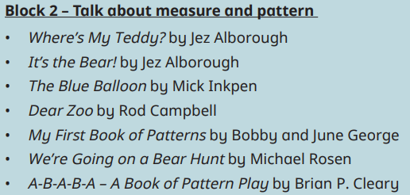  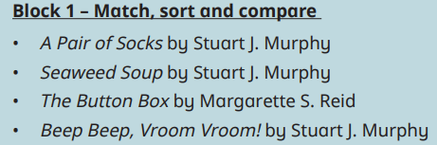 | 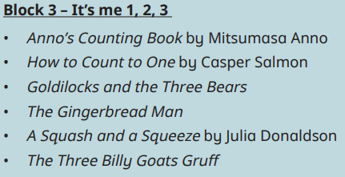  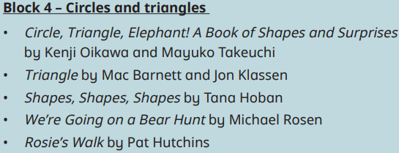  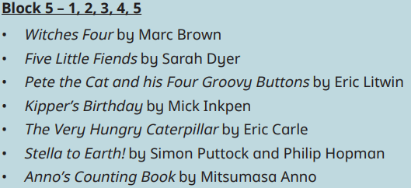  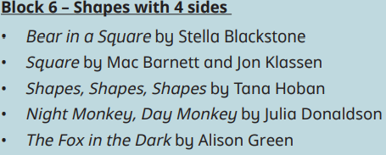 | 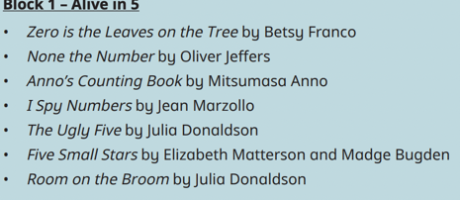  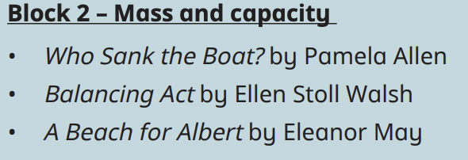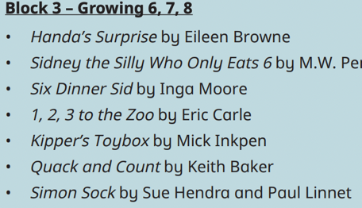  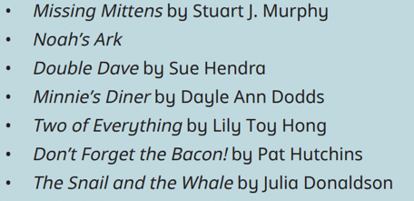  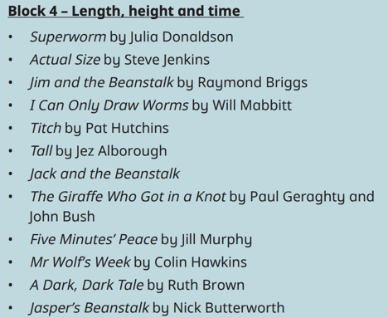 | 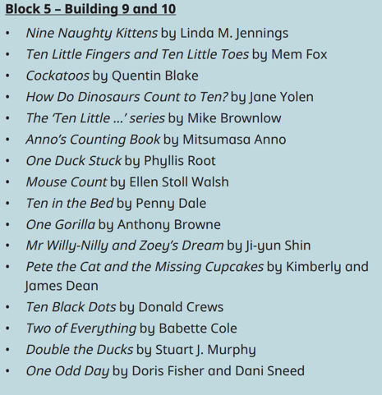  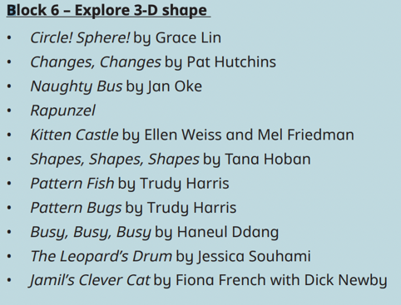 | 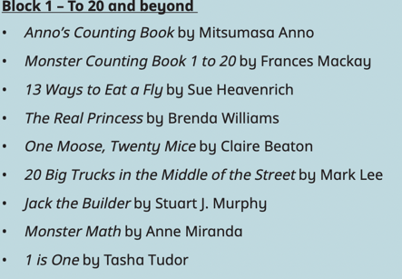  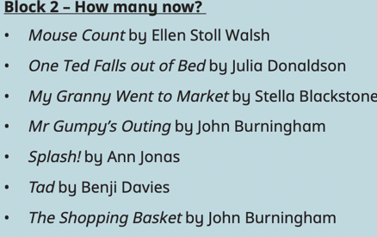  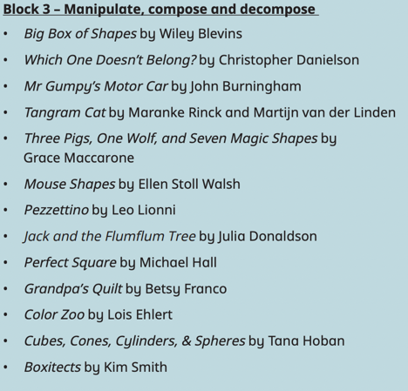 | 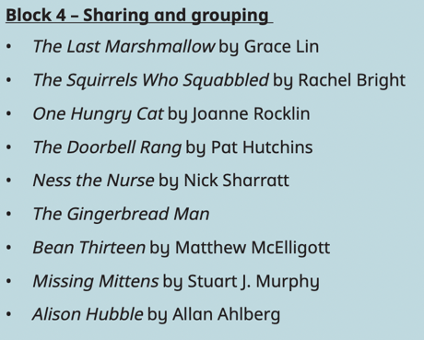  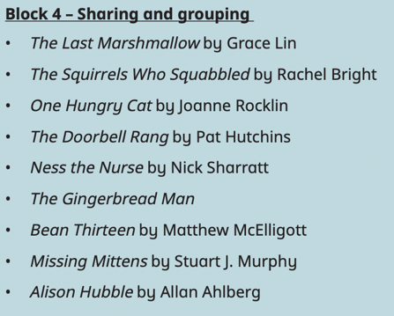  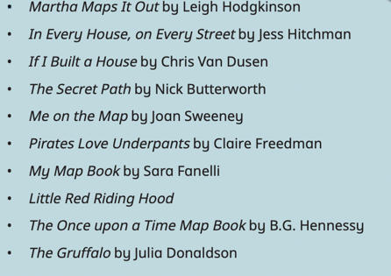  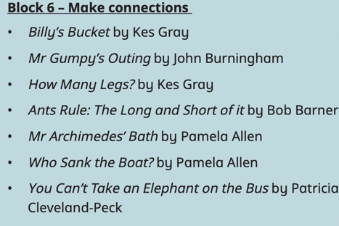
Possible Book list-WRM | Number: Have a deep understanding of number to 10, including the composition of each number. Subitise (recognise quantities without counting) up to 5. Automatically recall (without reference to rhymes, counting or other aids) number bonds up to 5 (including subtraction facts) and some number bonds to 10, including double facts.  Numerical Patterns: Verbally count beyond 20, recognising the pattern of the counting system. Compare quantities up to 10 in different contexts, recognising when one quantity is greater than, less than or the same as the other quantity. Explore and represent patterns within numbers up to 10, including evens and odds, double facts and how quantities can be distributed equally.
Understanding the World    R.E- Somerset AMV | History: Past and Present  Children will know about their own life story and how they have changed.  Know when things have happened in their recent past e.g. “Back in Autumn we...”  Know about the physical changes of themselves over time.  Talk about the lives of people around them and their roles in society.  Little People, Big Dreams: Usain Bolt  Geography: People, Culture and Communities  Children will know about features of the immediate environment.  Science: The Natural World  Children will understand the terms ‘same’ and ‘different’ and talk about seasonal changes.  Making observations and asking questions about the familiar, the place we live and the natural world  Identify everyday materials e.g glass, brick, rock, paper, plastic, metal, clay and cardboard for particular uses  Investigate different materials, which material is best to build a house from?  RE: People, Culture and Communities  Special Me  Me boxes  Special things, special people.  Where do I belong? | History: Past and Present  Children will know some similarities and differences between things in the past and now.  Know some similarities and differences between things in the past and now, drawing on their experiences and what has been read in class.  Understand the past through settings, characters and events encountered in books read in class and storytelling.  Little People, Big Dreams: Usain Bolt  Geography: People, Culture and Communities  Children will know that people around the world have different religions.  Draw maps of story settings  Tracks and trails- animal footprints, following arrows  Use a map to locate countries and habitats of wolves  Science: The Natural World  Children will explore and ask questions about the natural world around them. Light and dark.  Talk about why things happen and how things work  Developing an understanding of growth, decay and changes over time  What’s the difference between a wolf and a dog?  What can we learn from animal teeth and bones? What do wolves eat? What is their habitat? What about bears? Do they live in the UK? Polar bears?  Hibernation- which animals hibernate in this country?  Weather and seasons  RE: People, Culture and Communities  Special Times  -Birthdays  -Hannukah  -Christmas  -Diwali | History: Past and Present  Children will Talk about the lives of people around them and their roles in society.  Little People, Big Dreams: Florence Nightingale  Geography: People, Culture and Communities  Children will know about people who help us within the community.  Science: The Natural World  Children will know some important processes and changes in the natural world, including states of matter.  What do our teeth do? How can we look after our teeth?  identify and classify- which animals have babies? Which animals lay eggs?  RE: People, Culture and Communities  Special Places  -My special place  -Church buildings (visit)  -Baptism  -Synagogue | History: Past and Present  Children will talk about past and present events in their lives and what has been read to them.  Know that their local area has changed over time.  Little People, Big Dreams: Florence Nightingale  Geography: People, Culture and Communities  Children will know that there are many countries around the world.  Why do birds migrate? Link to seasons and temperatures around world.  We will explore our local area and discover the human and physical features. What is in Frome? We will create our own maps  We will discover the 4 capitals and countries of the UK.-Loch Ness, Mountains, Build Severn Bridge, Tower Bridge, Big Ben, Eiffel Tower  We will explore other countries  We will use maps and books, photographs  Science: The Natural World  Children will make observations about plants discussing similarities and differences.  Talking about things we have observed inc. plants, animals, natural and found objects  compare and group together a variety of everyday materials on the basis of their simple physical properties  identify and classify- which animals have babies? Which animals lay eggs?  Which birds live in our local area? RSPB bird watch.  RE: People, Culture and Communities  Special Times  -Passover  -Easter | History: Past and Present  Children will know about the past through settings and characters.  Famous explorers. Compare and contrast characters from stories, including figures from the past.  Little People, Big Dreams: Amelia Earhart  Geography: People, Culture and Communities  Children will know that people in other countries may speak different languages.  Know similarities and differences in relation to places  Talk about features of local environment and discuss how it varies from other environments.,  identify seasonal and daily weather patterns in the United Kingdom know the key physical features, including: beach, river, stream, pond moat, forest, hill, mountain, sea, ocean, soil, season and weather  know the key human features, including: city, town, village, factory, farm, house, beach, mountain, harbour and shop  We will create simple maps of the Snail and the Whale’s journey, the local area.  Science: The Natural World  Children will talk about features of the environment they are in and learn about the different environments.  Show care and concern for living things and the environment  RE: People, Culture and Communities  Special Stories-God  -Our world  -Our creation  -Order of creation  -Caring for our world | History: Past and Present  Children will know about the past through settings, characters and events.  Little People, Big Dreams: Amelia Earhart  Geography: People, Culture and Communities  Children will know that simple symbols are used to identify features on a map.  Science: The Natural World  Children will make observations about animals discussing similarities and differences.  Show care and concern for living things and the environment  Lifecycle of caterpillar to butterfly, tadpole to frog  Plant sunflower and bean seeds, lifecycle of a bean  identify and classify- which animals have babies? Which animals lay eggs?  RE: People, Culture and Communities  Special Stories-Jesus  -Disciples  -House on the rock  -Healing man with leprosy  -Jesus prays  -Jesus teaches about love  .
Past and Present: Talk about the lives of the people around them and their roles in society. Know some similarities and differences between things in the past and now, drawing on their experiences and what has been read in class. Understand the past through settings, characters and events encountered in books read in class and storytelling.

People, Culture and Communities: Describe their immediate environment using knowledge from observation, discussion, stories, non-fiction texts and maps. Know some similarities and differences between different religious and cultural communities in this country, drawing on their experiences and what has been read in class. Explain some similarities and differences between life in this country and life in other countries, drawing on knowledge from stories, non-fiction texts and (when appropriate) maps.

The Natural World: Explore the natural world around them, making observations and drawing pictures of animals and plants. Know some similarities and differences between the natural world around them and contrasting environments, drawing on their experiences and what has been read in class. Understand some important processes and changes in the natural world around them, including the seasons and changing states of matter.

Expressive Arts and Design    ‘Sing Up’ | Music: Being Imaginative  Children will sing and perform nursery rhymes and songs with actions.(Harvest festival)  Sing Up - I’ve got a grumpy face (3)  Timbre, beat, pitch contour.  Sing Up - Witch, witch (3)  Call-and-response, pitch (la-so-mi-do), timbre  Art & Design: Creating with Materials  Children will experiment with Drawing  Skills:  *Draw from memory, observation and the imagination  *Have opportunities to draw using art materials such as soft pencils, coloured pencils, felt-tip pens, biros, crayons, charcoal, chalk pastels and oil pastels  *Have opportunities to use other materials for drawing such as ribbons, skipping ropes, beads, mark making in sand, water on a dry playground surface etc.  *Experience drawing on a variety of surfaces and on both a very large and very small scale  *Be able to identify shapes, pattern, lines, light and dark in their drawings and describe marks eg curly, fat, thin, soft. | Music: Being Imaginative  Children will experiment with different instruments and their sounds. (Christmas play)  Art & Design: Creating with Materials  Children will experiment with Painting  Painting- Artist Study- Van Gogh Starry Night/Sunflowers  Skills:  *Have opportunities to make art using colour including with ready mixed paint, watercolour tins, felt tip pens, crayons and oil pastels  *Have opportunities to use different tools to apply paint, including for example fingers, paint brushes, sticks, cotton buds and paint brushes in a range of sizes from very tiny to large decorating brushes  *Learn that adding white makes a colour lighter and adding black makes it darker  *Be able to name a range of primary and secondary colours and talk about which colours they like and why | Music: Being Imaginative  Children will create narratives based around stories. (Stone soup)  Cuckoo Polka  Sing Up - Bird spotting: cuckoo polka (3)  Active listening, beat, pitch (so-mi), vocal play.  Art & Design: Creating with Materials  Children will safely explore different techniques for Printmaking  Printing Artist Study– Rover Thomas – aboriginal art  Skills:  *Be able to make a print by loading an object with paint and applying it to a surface  *Make repeating patterns using different objects such as found objects, cut fruit and vegetables and by making handprints and footprints  *Be able to print patterns by pressing objects into clay  *Have the opportunity to make prints by rolling objects such as toy cars, tyres, marbles and tricycles | Music: Being Imaginative  Children will move in time to the music.  Sing UP Five fine bumble bees (3)  Timbre, tempo, structure (call-and-response), active listening.  Art & Design: Creating with Materials  Children will make props and costumes for different role play scenarios.  Textiles  Skills:  *Have opportunities to use fabrics, ribbons and threads to make art  *Learn the basic principle of weaving eg on a fence or on a card weaving loom  *Learn the basic principle of sewing eg on a sewing card  *Learn how to thread beads onto string or ribbon  *Be encouraged to sort and name different kinds of fabrics by textures and colours  *Identify and talk about textiles in the world around them, eg clothes, carpets, and curtains | Music: Being Imaginative  Children will play an instrument following a musical pattern.  Sing Up - Down there under the sea (3)  Timbre, structure, active listening, tune moving in step (stepping notes), soundscape.  It’s oh so quiet  Dynamics, timbre, musical storytelling, improvising and composing, exploring instruments  Art & Design: Creating with Materials  Children will explore and use a variety of artistic effects to express their ideas and feelings.  Collage  Skills:  *Have opportunities to make pictures and patterns by cutting and sticking a variety of materials eg wallpaper, cellophane, tissue paper  *Be able to cut and tear paper and thin card  *Learn how to apply the right amount of glue for sticking  *Be able to sort materials for collage by colours and textures  *Learn how materials such as sand, gravel and glitter can be sprinkled onto a patch of glue and then tipped off | Music: Being Imaginative  Children will invent their own narratives, stories and poems.  Sing Up - Slap, clap, clap (3)  Music in 3-time, beat, composing and playing  Art & Design: Creating with Materials  Children will share creations, talk about process and evaluate their work.  3D Sculpture  Skills:  *Have opportunities to build using construction kits, junk materials and natural materials  *Have opportunities to model using different modelling materials such as plasticine, clay or dough  *Learn how they can cut malleable materials with a blunt knife or scissors  *Experiment with ways of joining materials and objects together  *Learn how they can make patterns by pressing objects and tools into modelling materials and by pressing modelling materials into moulds  *Explore the properties of clay, including how it becomes soft with water and hardens when dry. Recognise objects made from clay eg ornaments, tiles and pottery.
Creating with Materials: Safely use and explore a variety of materials, tools and techniques, experimenting with colour, design, texture, form and function. Share their creations, explaining the process they have used. Make use of props and materials when role playing characters in narratives and stories.
Being Imaginative: Invent, adapt and recount narratives and stories with peers and their teacher. Sing a range of well-known nursery rhymes and songs. Perform songs, rhymes, poems and stories with others, and (when appropriate) try to move in time with music.

